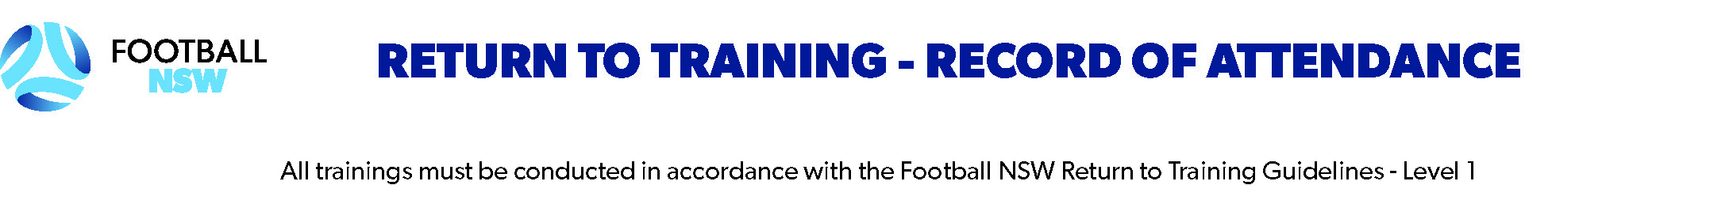

Name of Club: Team/Age Group:
Week commencing: Completed by:
ALL PERSONS ATTENDING MUST BE RECORDED (INCLUDES COACH, PLAYERS, PARENTS, CARERS, OFFICIALS, SPECTATORS, VOLUNTEERS)

NAME |  |  | FFA # | COVIDSAFE APP? | ARRIVAL TIME | DEPARTURE TIME
First |  | Surname
1
2
3
4
5
6
7
8
9
10
11
12
13
14
15
16
17
18
19
20

To further aid the fight against COVID-19, Football NSW supports the Australian Government’s COVIDSafe app and strongly encourages all members of the football community to get behind this initiative.
The app can be downloaded from the Apple App store and Google Play.

